**Quick Start**

1. Download and install ViVi Robot App

The App support for both Android device and iOS device, including phone and tablet.

You can download ViVi Robot App for Android from the following links:

* <https://play.google.com/store/apps/details?id=jp.doit.scenography&hl=zh_CN>
* <https://www.pgyer.com/qIYq>

Download ViVi Robot App for iOS from the App Store:

* <https://itunes.apple.com/us/app/vivi-robot/id1255421040?l=zh&ls=1&mt=8>

Learn more:

* <http://plen.jp/playground/wiki/tutorials/index.html>

1. Connect your phone to Robot’s AP

The Robot works as AP. When ViVi Robot power up, wait for about 5 seconds, you can connect your phone with the Robot AP by changing WiFi SSID to the Robot AP, whose SSID shown as "ViVi-xxxx".

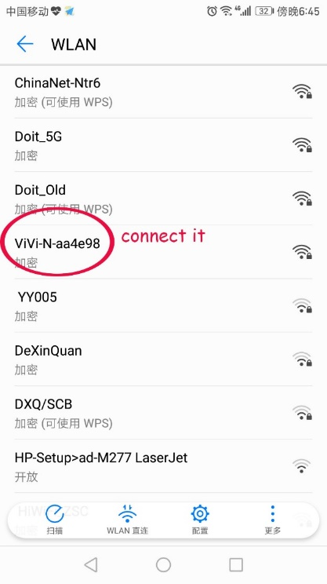

Default password for Robot AP is 123456798xyz

1. Robot Control via App

When your phone connect to the Robot AP successfully, run the App to connect with the robot by clicking the “connect robot” button on App.

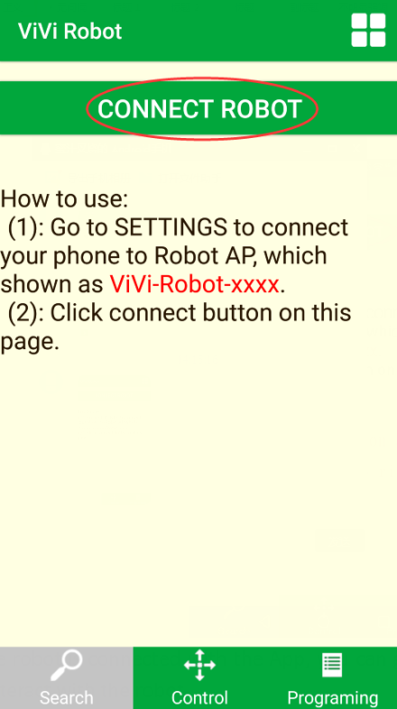

After the robot is connected successfully, you can go to the controlling/programming page on App to interact with the robot.